Lane Corrections
Lane pos_582913874#0.52_1 shown on sumo as a left and right turn lane, Google Satellite shows this as a left turn only lane.
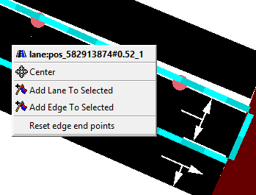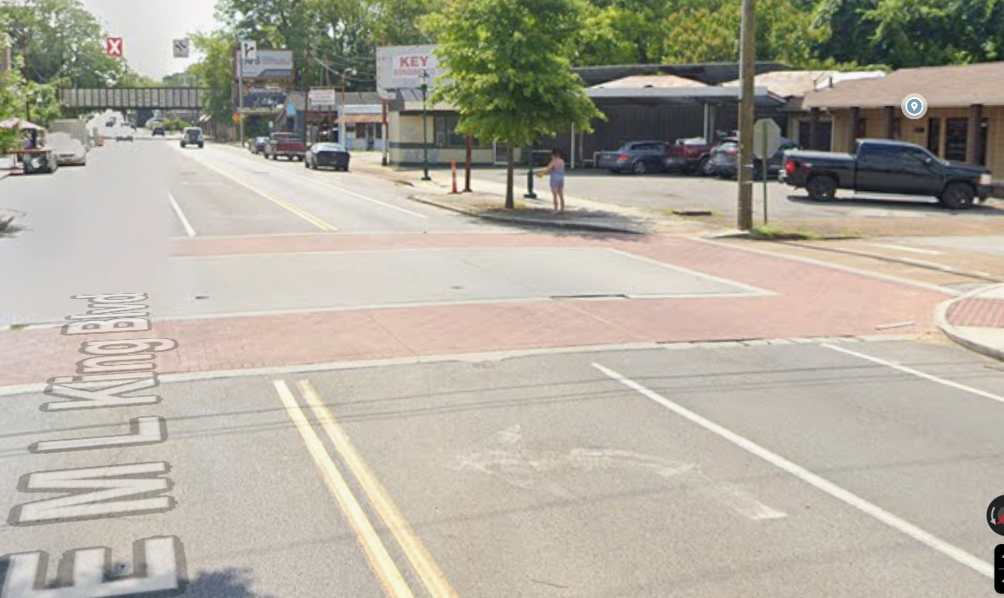

Lane E4_0 shown as a right turn lane, Google Satellite shows this as a straight and right turn lane.
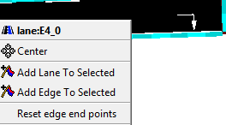
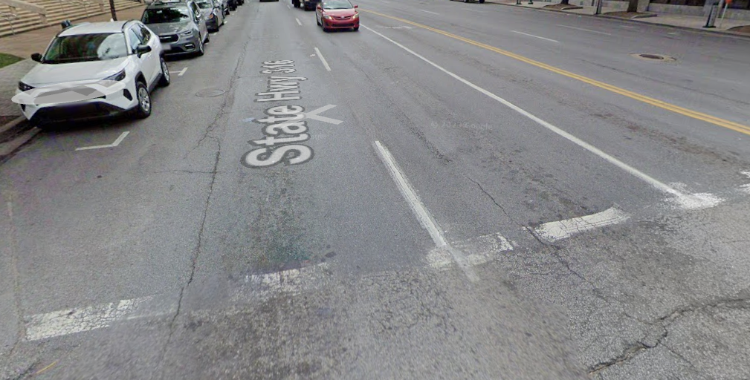
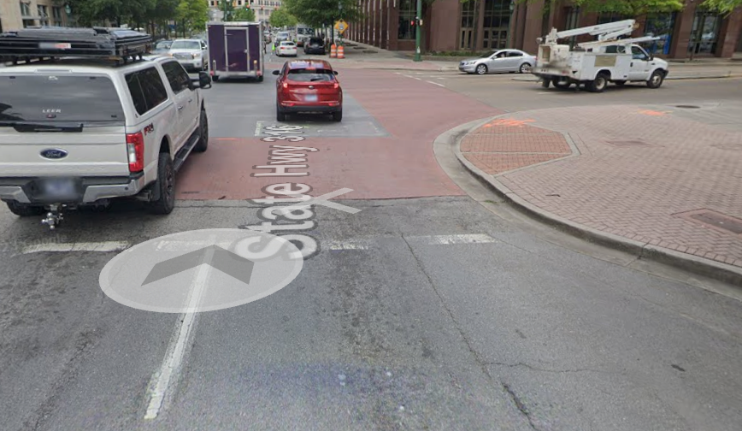

I also changed the speed limits of the lanes to be accurate with real world
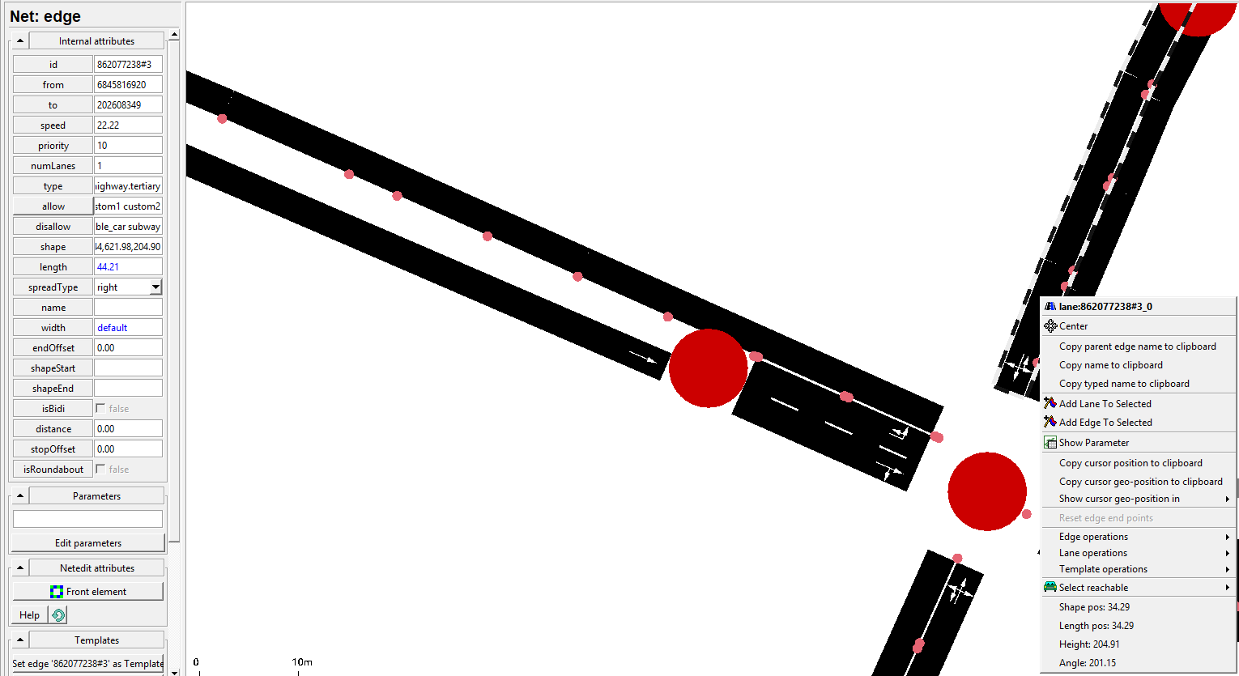this shows that a residential lane had the speed set to 22.22 I changed it to 11.176 to match the speed of the intersection.

I found this document online that shows the speed limits for the MLK blvd 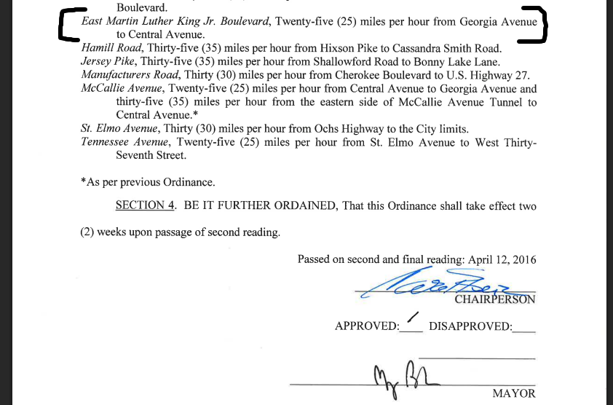
https://chattanooga.gov/sites/default/files/resources/13038-20Speed-20on-20Through-20Streets.pdf

I also shifted multiple lanes so that they can be accurate with real world image and be smooth at their junctions. Here is an example of a few
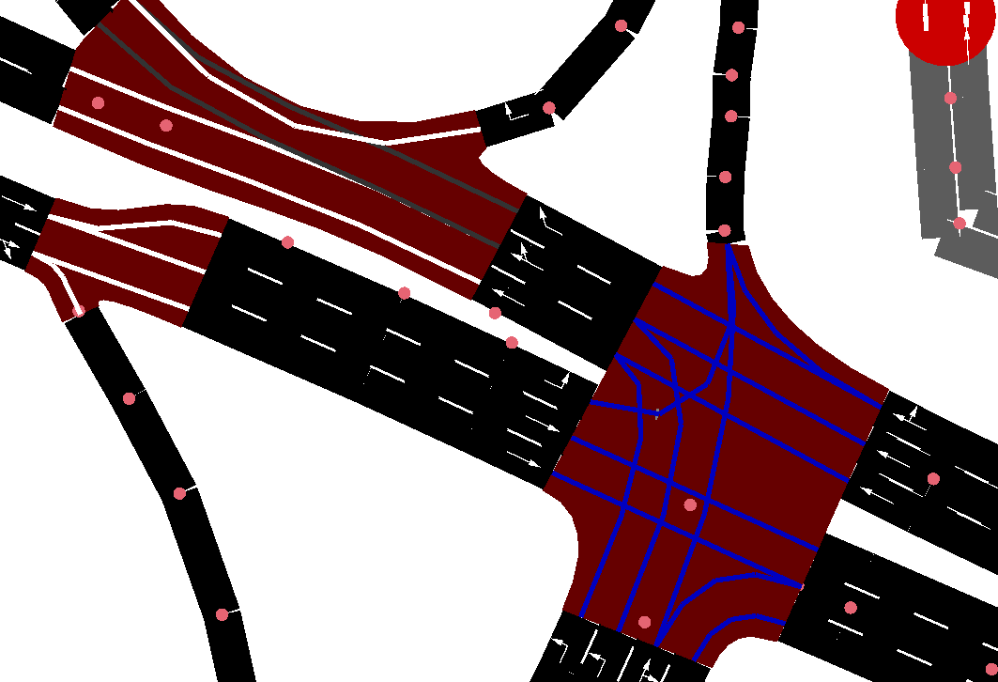
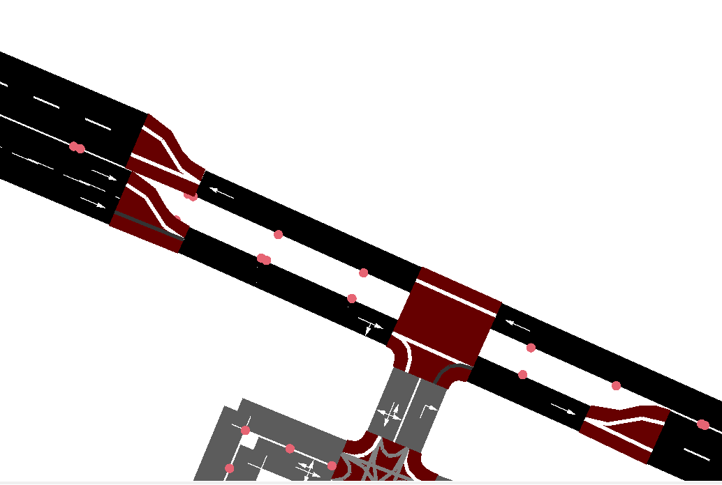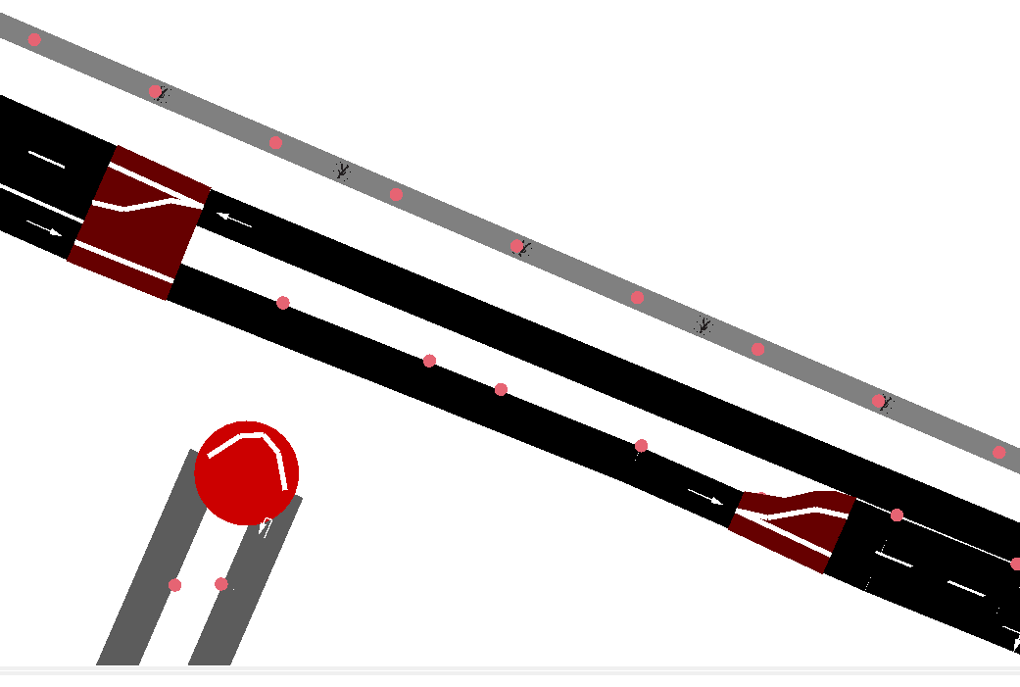
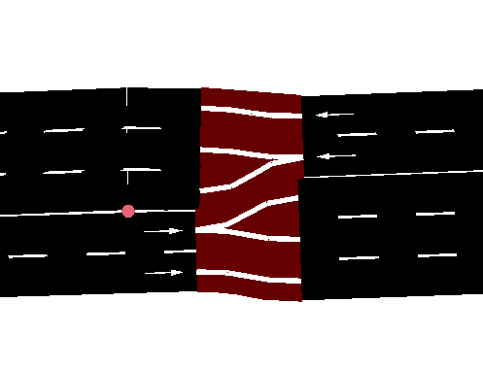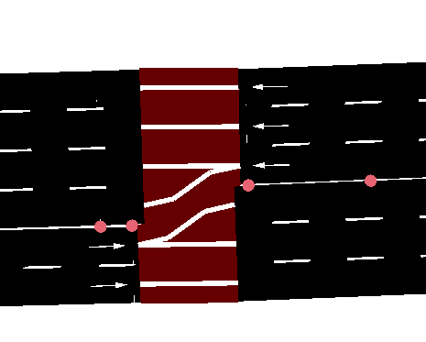
Edge 51067082#1_0 changed the number of lanes from 3 to 2 because on google satellite it shows that it is 2 lanes
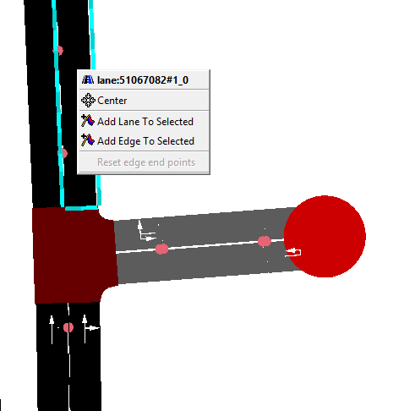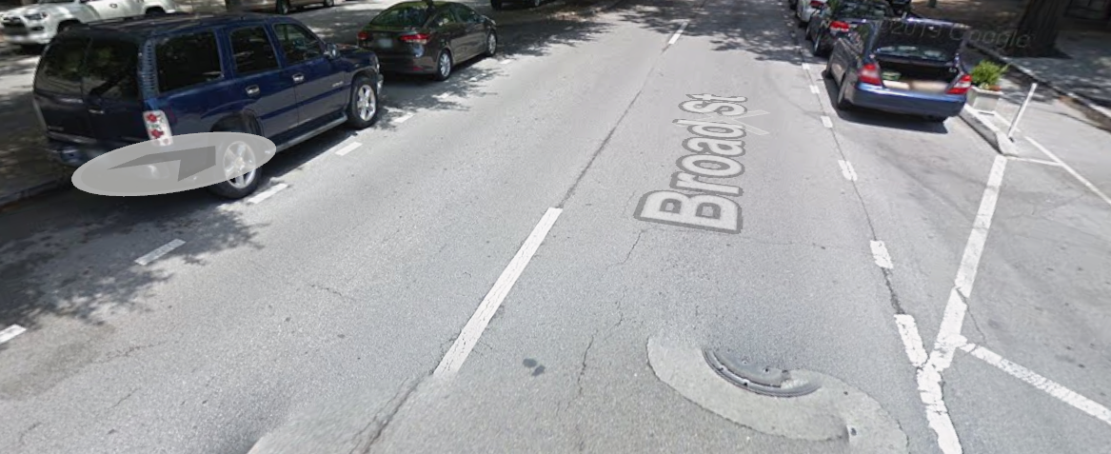the other two lanes shown are meant for parking.

